Statement |  |  |  |  |  |  | Date: January 9, 2022
National Pan Hellenic Council Chicago  P.O. Box 438966  Chicago, IL 60643 |  |  | Comments: |  |  |  | Bill To: |  | List your Chapter name here
Date | Description |  |  |  |  |  |  | Balance |  | Amount
 | 0 |  |  |  |  |  |  | $100.00 |  | $100.00
Payments | Mail to PO BOX
 | Paid
 |  |  |  |  |  |  |  |  |  | Amount Paid
 |  |  |  |  |  |  |  |  |  | 100.00
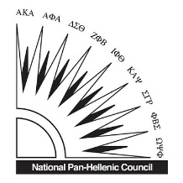 |  |  |  |  |  | Remittance
 |  |  |  |  |  | Due Date
 |  |  |  |  |  | Amount Paid |  |  | $100
 |  |  |  |  |  | Amount Enclosed
Make all checks payable to National Pan Hellenic Council Chicago
Thank you for your business!

